Bug_id_01
Bug Description:
After successful login, the Home Page displays "Welcome Muhammad" instead of the logged-in user’s actual name (Abdul Ahad). This indicates either hardcoded placeholder text or a session/profile data mismatch.
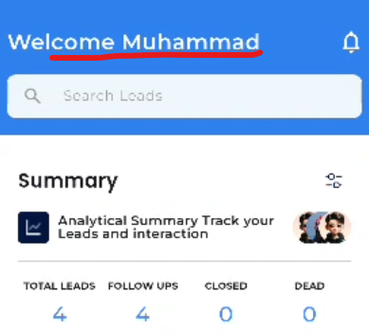

Bug_id_02
Bug Description:
The notification icon (bell/symbol) on the Home Page’s top-right corner is non-functional, tapping it does not open any notification panel, dropdown, or navigate to a notifications screen.
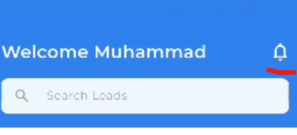

Bug_id_03
Bug Description:
On the Home Page, the profile pictures/icons on the right side are disproportionately larger compared to the text and summary cards on the left, causing visual imbalance and poor layout alignment.
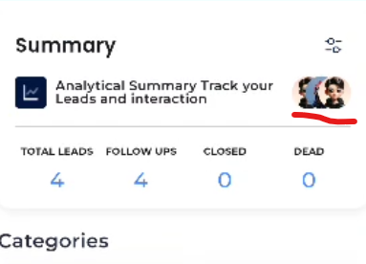
Bug_id_04
Bug Description:
The search bar on the home page does not work. Typing any text does not filter leads or show any results. The search feature is completely non functional.
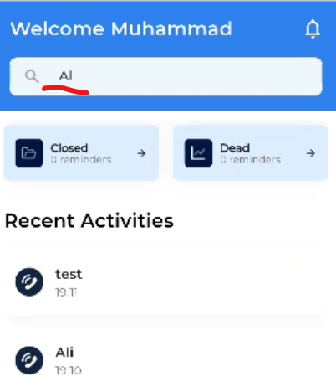
Bug_id_05
Bug Description:
When the phone is rotated to horizontal mode on the home page, the welcome section becomes sticky and does not scroll properly. This blocks half of the screen and makes the rest of the content difficult to view and interact with.
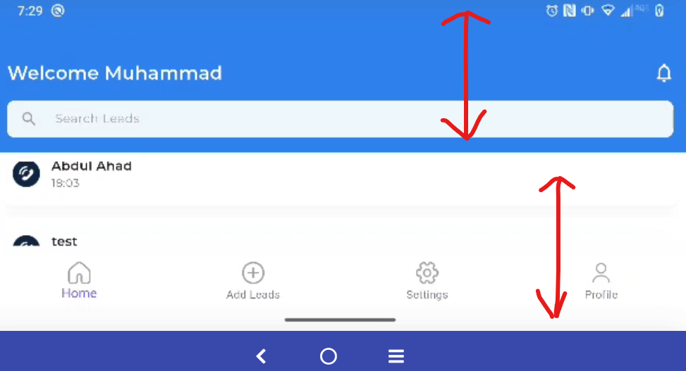
Bug_id_06
Bug Description:
On the Home page filter, the "Leads" field is pre-selected with "Cold Leads" by default. This is incorrect because it gives the impression that a filter is already applied when the page loads, which may confuse the user.
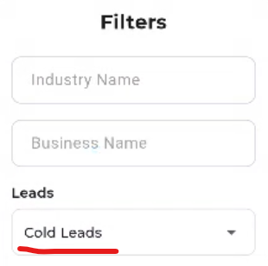

Bug_id_07
Bug Description:
When opening the filter on the Home page and clicking on Industry or Business fields, the entire filter UI becomes distorted, misaligned, or unreadable, making it impossible to use.
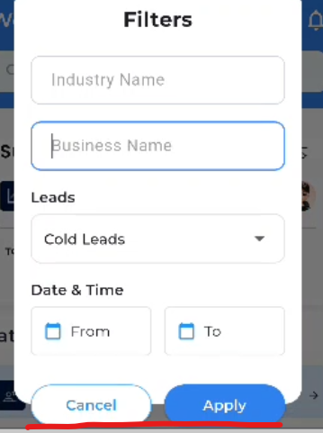

Bug_id_08
Bug Description:
The Lead filter only shows three options: Hot, Warm, Cold. It is missing the "Dead" option, which is required for complete lead status filtering.
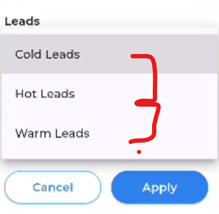
Bug_id_09
Bug Description:
On the Home page, the Lead Status filter displays options as "Cold Leads", "Hot Leads", and "Warm Leads" — each including the word "Leads" as a suffix.
On the Leads page, the same filter shows "Cold", "Warm", and "Hot" — without the suffix, creating a mismatch in terminology across the app.
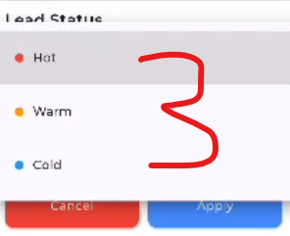
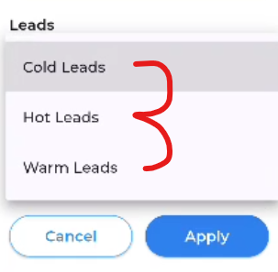

Bug_id_10
Bug Description:
The Home page filter shows plain text without bullets or any visual markers, resulting in an inconsistent look and feel between the two pages.
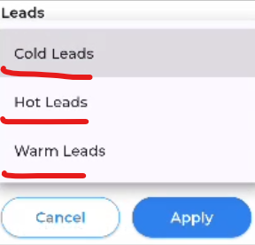
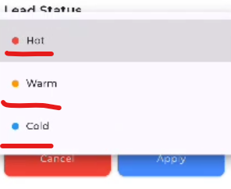
The Leads page filter presents each status option with colored bullet points next to the text, adding visual distinction.
Bug_id_11
Bug Description:
The filter section is labeled inconsistently on two pages:
- On the Home page, it is titled "Leads".
- On the Leads page, it is titled "Lead Status".
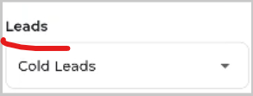
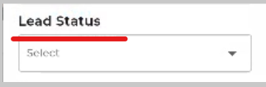
This mismatch in labeling for the same filter type creates confusion and breaks UI consistency.
Bug_id_12
Bug Description:
The Home page does not support pull-to-refresh or any manual refresh gesture. Users cannot update leads, follow-ups, or summary data without restarting the app.

Bug_id_13
Bug Description:
The Home page does not support pull-to-refresh or any manual refresh gesture. Users cannot update leads, follow-ups, or summary data without restarting the app.

